**Publishing the wasm sample in github pages.**

1. Create and build the diagram sample in wasm.
2. Publish the sample. Please refer the properties.
   1. Overview 
      Connected Services 
      Publish 
      Folder 
      + New More actions • 
      Successfully published on 3/30/2021 at 4:33 PM. 
      Settings 
      Target location 
      Delete existing files 
      Configuration 
      Target Framework 
      Target Runtime 
      Show all? 
      True 
      Release 
      netstandard2. I 
      Portable 
3. Create the github repository with readme file.
4. Copy and paste your published folder(bin\Release\netstandard2.1\publish\wwwroot) to seperate folder.
   1. Sample file format

O _content 
O framework 
sample-data 
.gitattributes 
d] .gitignore 
.nojekyll 
debug 
diagram 
favicon 
index 
Iodash.min 
README.md 

1. Add the .gitattributes file in root folder with below comment

\* binary  
autocrlf=false

1. Add .nojekyll file to root folder
   1. Please refer the newly added files in the location.

<https://www.syncfusion.com/downloads/support/directtrac/general/7z/NativeDiagramWasmPublish-784371371.7z>

1. Remove base tag on your index.html file
2. Commit the file to github repo. Then go the settings. Choose the branch and folder then after save the changes.

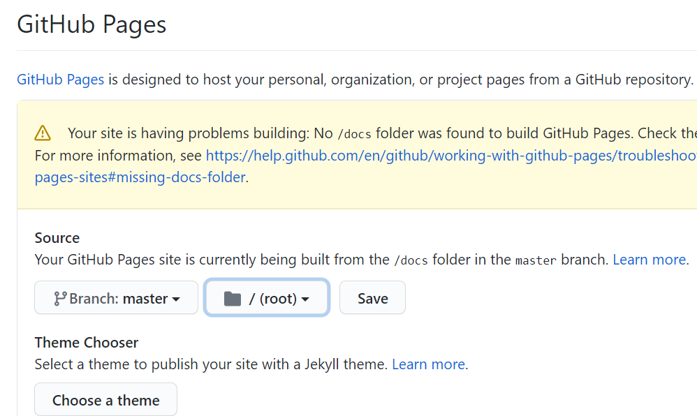

1. After the save, the page was refresh. It will piublished and published site is shown like this. Use the link to show the sample.

1. 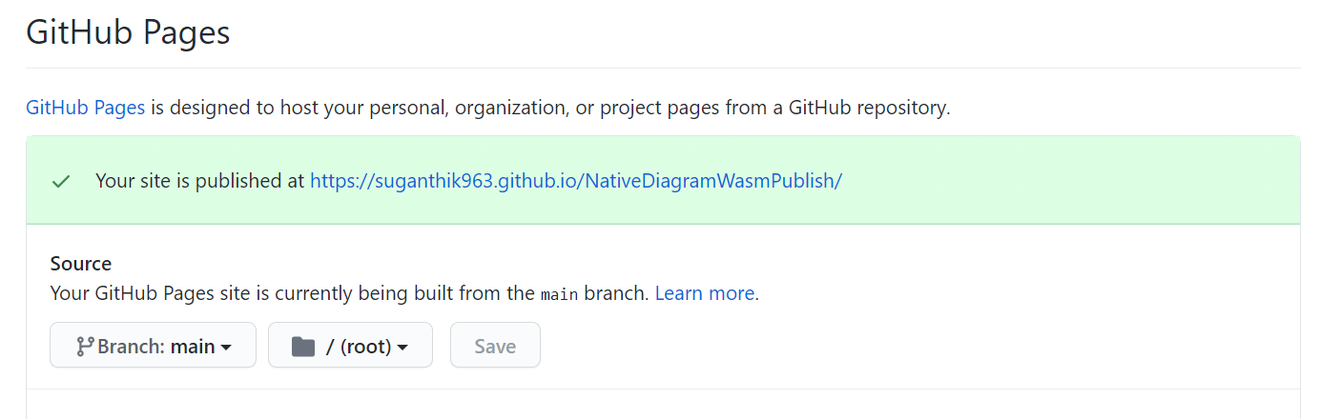
2. If any issue to publish to run the below comment(optional)
   1. "git add --renormalize ."

Please refer the sample link.

[SuganthiK963/NativeDiagramWasmPublish (github.com)](https://github.com/SuganthiK963/NativeDiagramWasmPublish)